Save the Date

18th Consultative Forum
“The Interconnectivity of Climate Change and Natural Catastrophes: How insurance is responding to build resilience and bridge the protection gap”

23 October 2023
Accra, Ghana

The devastating impact of climate change has already become a reality for many, and even more the most vulnerable societies and households. Addressing the widening protection gaps requires close collaboration between the public and private sector. Thus, bringing together key stakeholders to share their knowledge and experience in addressing climate change related risks is more important than ever.
The Consultative Forum 2023 will gather representatives of international initiatives, the insurance industry as well as policymakers and supervisors to jointly identify best practices, challenges and opportunities for developing and implementing insurance solutions that can promote financial resilience in the face of climate change and natural disaster.

Who should attend?
Senior representatives of insurance regulatory and supervisory authorities, supervisors from other relevant sectors, policymakers, insurers, brokers, climate change experts, aggregators, and international development partners.

What are the key themes?
The forum will start by looking at global initiatives like the Global Shield against Climate Risks and discuss the IAIS’ most recent work on NatCat Protection Gaps and supervisory approaches to help closing existing protection gaps. In addition, industry representatives will highlight the impact of new products and innovative services they have been developing to buffer the impact of climate change. A special focus will be put on the topic of risk modelling since one of the key elements for the insurance industry, but also for policymakers and other decision-makers is quantifying risks arising from natural catastrophes. In the light of climate change, risk modelling becomes more challenging as relying on historical data is no longer enough. For this reason, the session on risk modelling during the CF will be complemented by a half-day online training event in November for supervisors to deepen their knowledge on the topic.

What are the expected outcomes?
The event aims to produce a set of recommendations and best practices for addressing climate and disaster risks in inclusive insurance markets. These recommendations will be disseminated to the IAIS, A2ii, MiN and IDF networks and other stakeholders to inform policy and practice. In addition, the event will provide a platform for networking and knowledge exchange among participants, fostering collaboration and partnerships in this critical area.
Who are the hosts?
The upcoming Consultative Forum is jointly organised the Access to Insurance Initiative (A2ii) and the International Association of Insurance Supervisors (IAIS) in partnership with the Microinsurance Network (MIN), and the Insurance Development Forum (IDF). It will take place alongside the International Conference on Inclusive Insurance in Accra, Ghana. The conference will be jointly hosted by the National Insurance Commission of Ghana (NIC), the Ghana Insurers Association (GIA) and the Insurance Brokers’ Association of Ghana (IBAG) in cooperation with the Munich Re Foundation and the Microinsurance Network.

How to register?
To attend the Consultative Forum, you have to be registered for the International Conference on Inclusive Insurance. Please register for the conference here.
Select the pre-conference you would like to attend on the second page of the registration form:
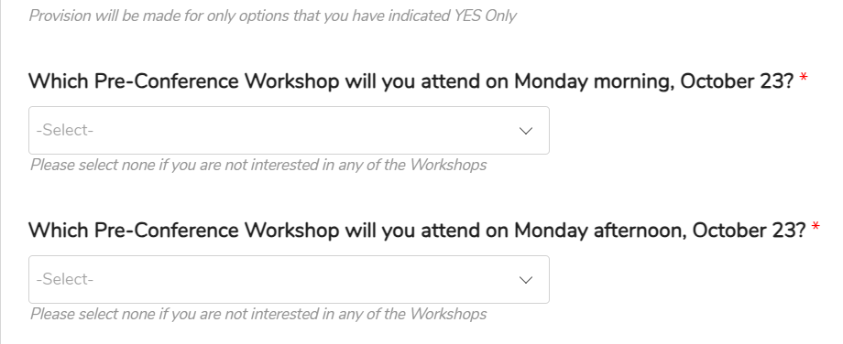
To join the Consultative Forum please select Workshop 3: The interconnectivity of climate and natural catastrophes:
